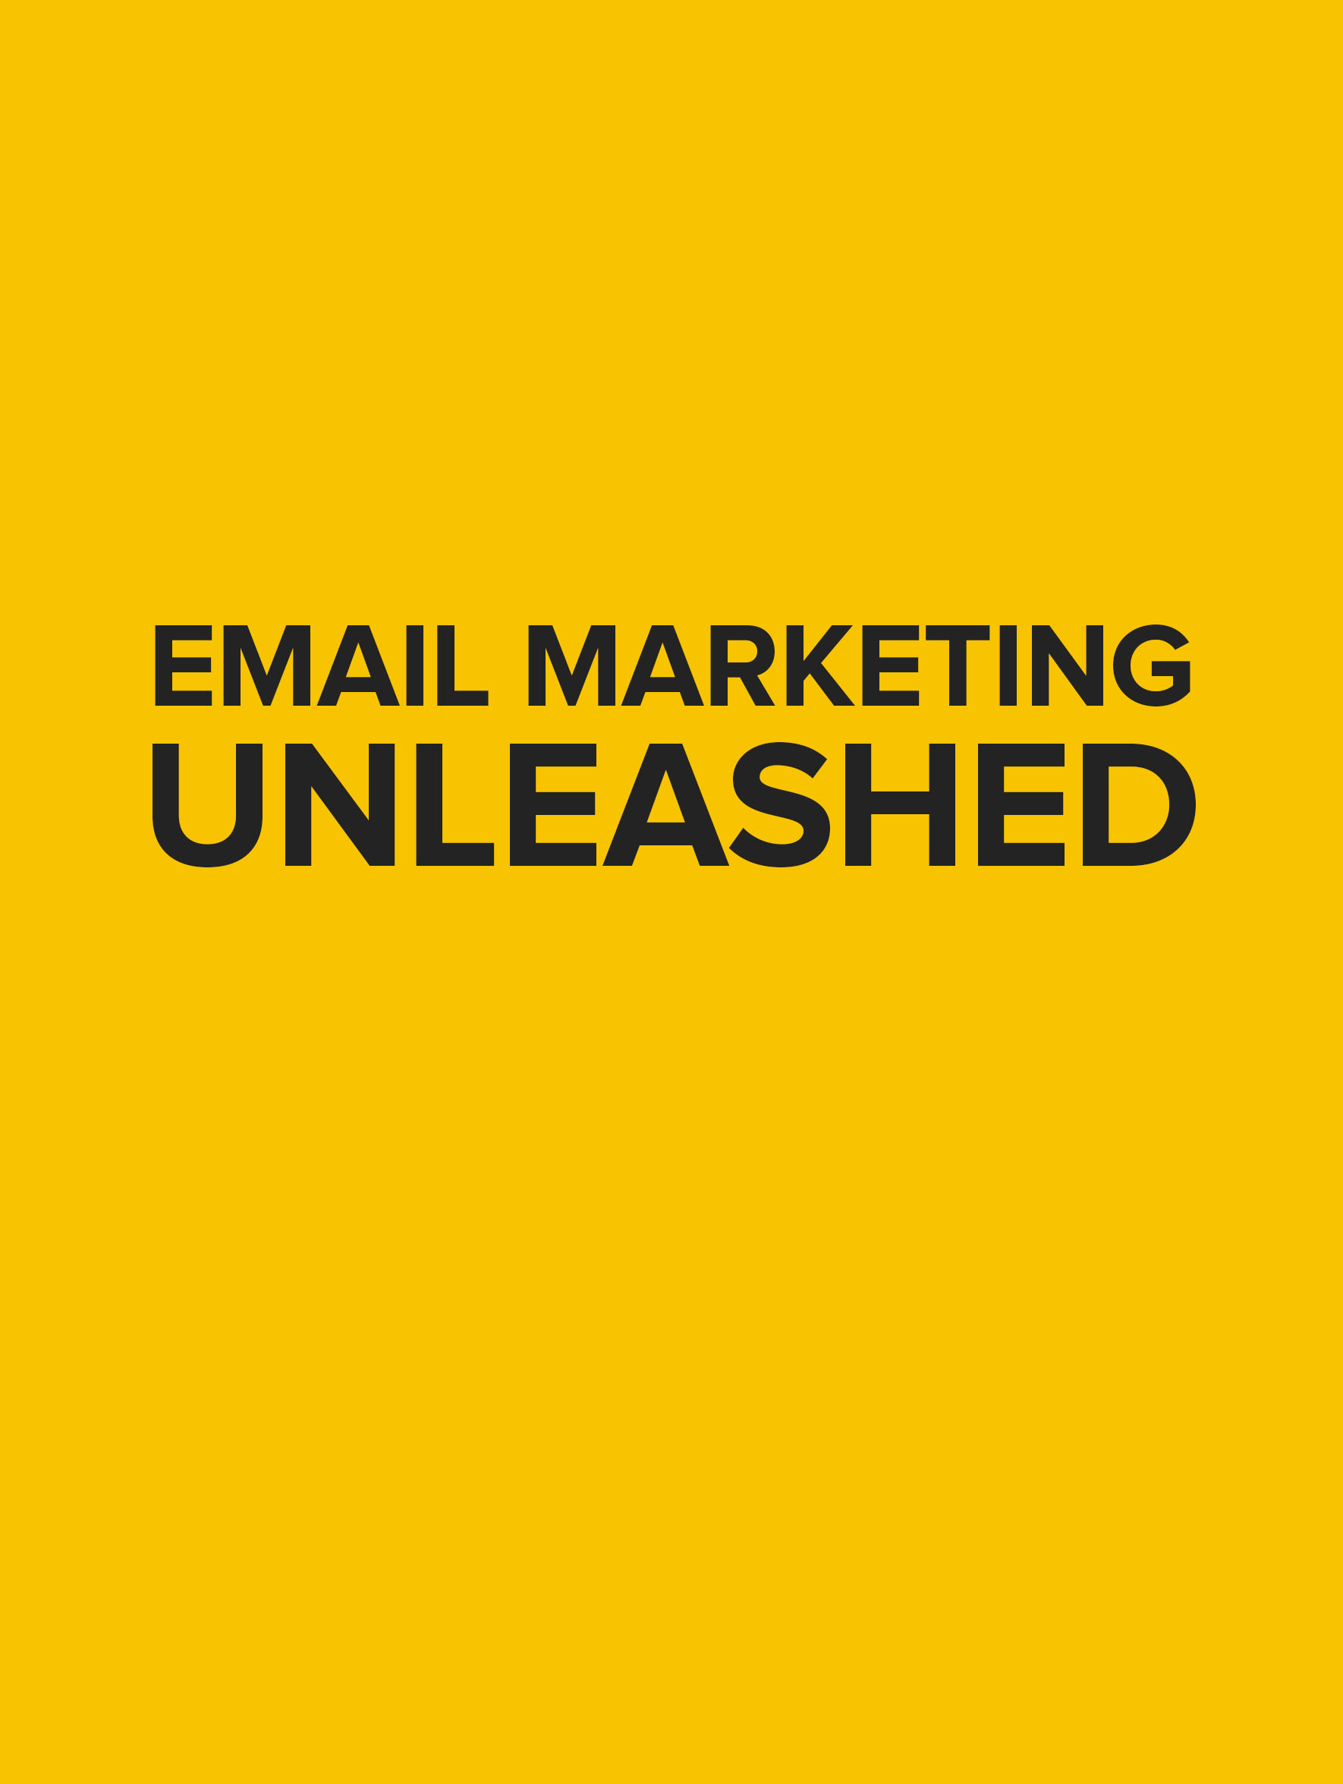­­­

**DISCLAIMER**

The Publisher has strived to be as accurate and complete as possible in the creation of this report, notwithstanding the fact that he does not warrant or represent at any time that the contents within are accurate due to the rapidly changing nature of the Internet.

The Publisher will not be responsible for any losses or damages of any kind incurred by the reader whether directly or indirectly arising from the use of the information found in this report.

This report is not intended for use as a source of legal, business, accounting or financial advice. All readers are advised to seek services of competent professionals in the legal, business, accounting, and finance fields.

No guarantees of income are made. Reader assumes responsibility for use of information contained herein. The author reserves the right to make changes without notice. The Publisher assumes no responsibility or liability whatsoever on behalf of the reader of this report.

This report may contain affiliate programs and advertisements for monetization, which can result in commissions or advertising fees being earned for purchases made by visitors that click through any of the advertisements and/or links included in this text.

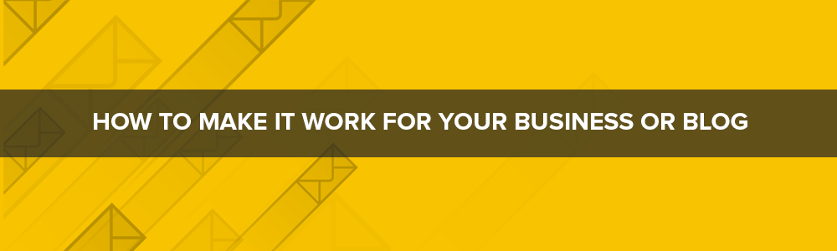

Email marketing is a strange beast in the world of digital marketing. That’s because it’s something that every marketing expert *raves* about and that many describe as the single most important tool they use to build their audience and make sales. The stats surrounding email marketing are incredibly impressive and there is a ton of advice out there if you’re looking for it.

But despite all this, it’s also something that a large number of businesses, marketers and bloggers just ignore. So why is that?

Well, simply put, it’s because a lot of businesses just don’t *get* email marketing. How can they expect to make a lot of money from sending emails? Why would anyone bother signing up? What should they even put in an email?

Better to just stick with what you know, right?

Well, sure… if you want to miss out on creating a direct relationship with your fans and customers and if you want to drastically reduce your revenue… then go ahead!

Otherwise, it’s worth learning about email marketing so that you *do* get it and then employing some kind of actual strategy to ensure you’re targeting the right people in a way that they will actually be likely to stand up and take notice of.

That is the aim of this report: to supply you with the precise knowledge you need to *actually* understand email marketing and to start making it work for you efficiently.

**Some facts about email marketing:**

E-mail marketing has a ROI of 4,300%

91% of consumers will check their e-mail AT LEAST once a day…

Surveyed companies rate e-mail marketing as more profitable than: PPC advertising, content marketing, affiliate marketing, display advertising, mobile ads, social media marketing or direct marketing…

66% of US consumers above the age of 15 say they have made purchases as the direct result of an e-mail campaign…

1/3rd of consumers say they open e-mails based on the heading alone!

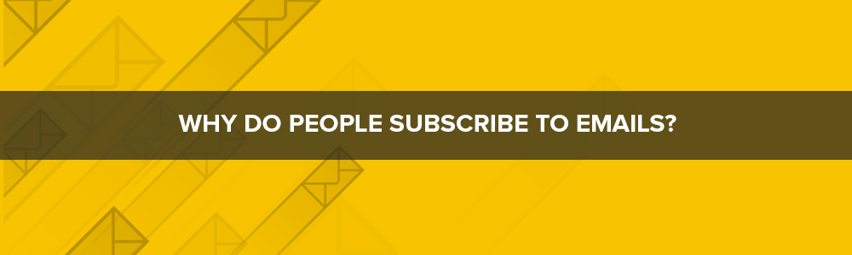

So now you know why you need to start spending time on email marketing, the next thing is to understand why it is that people subscribe to emails in the first place and therefore, how you can convince people to be interested in *your* mailing list.

This is *very* important too. Some businesses and entrepreneurs will make the mistake of thinking that they can ‘trick’ people into signing up for their mailing list, or that they can persuade them with free downloads etc.

And sure, both of those things might work in terms of pure numbers.

But if there’s one thing to understand about email marketing it’s that the *number* of subscribers isn’t really what counts. What *does* count is getting the right *quality* of subscribers so that the people who sign up for your mailing list will actually be likely to *read* what you send and so that they’ll be somewhat likely to buy from you as well.

If you had to choose between a massive mailing list that wasn’t well targeted or a small mailing list of highly engaged and interested subscribers then you should *always* pick the latter.

So why do people subscribe to emails of their own volition?

The answer, as is almost always the case with questions like these, is that they’re getting value by doing so. Your job then is to communicate the value they can get from your mailing list and to give them a good enough reason to want to subscribe.

When trying to persuade people to sign up for a mailing list, it is fairly common to use something called an incentive. This might mean an ebook, or it might be a free report. Either way, you can use this to offer value.

But the problem with this is that it can attract the wrong kind of reader sometimes. Sometimes this attracts subscribers who are only interested in getting that freebie and who will then never actually read your emails.

But what if the emails *themselves* were the incentives? What if your email list was so interesting, so engaging and so well targeted that people would want to sign up just so that they could get a chance to read the email?

You might think this would be impossible. After all, a mailing list is essentially just a marketing tool… right?

Allow me to show you a case study that demonstrates this doesn’t have to be the case.

**Case Study: Brain Pickings**

Brain Pickings is a website run by writer Maria Popova. On the site, Maria discusses all kinds of things that she is currently reading about or thinking about. One day she might discuss the nature of consciousness, another she might look at some of the principles of stoicism.

This actually started as a mailing list however: originally Maria was simply messaging her friends with some of her thoughts and things she found interesting that day. Apparently, this became so popular that it eventually spread around her colleagues and all her other friends and more and more people wanted to be invited to the mailing list. Once the list had grown to gigantic sizes, Maria made the decision to build a website and the rest is history!

As you can see then, Maria was able to build a massive audience simply on the strength of her content. People found what she had to say so interesting that they became loyal followers and eventually she was able to profit from that and quit her job.

The question is: how do you get to that point?



The answer is basically to do the reverse of what Maria did. Whereas Maria built a mailing list and then eventually used that to promote a website, it’s actually much easier to do the same in reverse. Just make sure that you *then* go on to provide the same high quality of content as Maria so that people want to keep reading your content and actually engaging with your messages.

Prior to this point though, you have to convince your visitors and your fans that they’ll *get* that kind of quality if they sign up to your mailing list. And the best way to do *that* is to make sure that you first deliver the quality on your website.

This is the basis of content marketing: you create engaging content that brings people to your website via search and via social media and then hope that people find it so useful and entertaining that they opt to seek out *more* of your content in future.

You can compare this to the basic principle behind ‘free samples’. If you have ever seen staff standing outside of Starbucks or Costa giving away free coffee or muffins then you’ll understand that their hope is to demonstrate how good their muffins and their coffee *are*. That way, you’ll then be motivated to come in and buy more.

Think of your blog posts and your articles as free samples then that can convince your readers that you’re capable of delivering amazing quality content and that they therefore ought to sign up.

Likewise, as the mailing list will often include news about your articles, you need to make sure that your articles are good enough and exciting enough that people would *want* to receive that news!

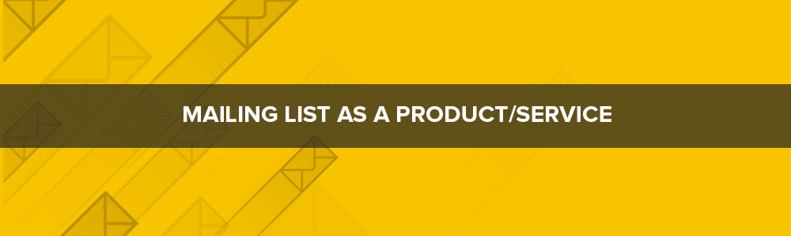

The mistake that a lot of marketers make is to view their mailing lists purely in terms of marketing. In other words, they use their mailing list to send out special offers and to remind people about their branding.

This has two problems. Firstly, it means people will very quickly become desensitized to the mailing list and will stop opening their messages. Secondly, it makes it hard to promote the mailing list – even if the content on the website is good.

So make sure then that your blog content is as exciting and interesting as your website content and try to think of it as its own service or product that could stand alone if necessary.

Once your mailing list becomes a product or a service, people will feel they’re getting a good deal by being able to download it for free and you’ll be able to more easily promote its highlights.

For instance, why not make your mailing list into an email course? You can create a course very easily using an autoresponder and you can make sure that you have a sales funnel at the end of the sequence.

Likewise, you could make your mailing list into an e-zine. This is basically a newsletter in PDF form but much longer - including full articles, beautiful images and professional formatting. Simply show people images of this e-zine and explain what’s in it and they’ll a) really want to subscribe to your mailing list and b) be excited to open each new message.

You can also give your mailing list inherent value in other ways. How about entering every one of your subscribers into a prize draw for instance? This way, they’ll have to open each message in order to find out if they’ve won and they’ll have a good reason to subscribe. Or alternatively, you could give away the *occasional* free gift. Instead of only giving away eBooks as incentives when you try to get people to sign up, this would mean that you occasionally send through PDFs and reports without reason or warning. This then means you can write in the subject heading that your email contains a free gift and you can attach a PDF. That way, people who maybe have stopped opening or looking out for your messages will notice that this one has something free and be *much* more likely to want to click and open it. At the same time, giving away things for free without saying that you’re going to is an excellent way to impress your readers and to generate good will. This is what you call ‘over-delivering’ – where you provide more value than you promise and thereby exceed expectations. This is a great strategy that lots of businesses could stand to benefit from.

Even if you do decide to make your emails more conventional as straightforward ‘newsletters’, it’s still important to make sure that you find ways to make them interesting and unique and to keep bringing people back and you still need to deliver great quality. Give your readers something that you’re not offering to your regular site visitors by going into your topics in a bit more depth or adding some extra content. Then go ahead and curate the content on your own website and from the industry/niche for their convenience.

If you’re really clever and you’re selling a product, you may even be able to get people excited to read about that product. If you do this, then your messages *can* be more conventionally ‘marketing-oriented’ while still getting people excited and delivering value.

How do you do this? By getting people excited for a forthcoming product release and then talking about it in such a way that will build anticipation and interest.

Imagine visiting a page that talks about a product that sounds *genuinely* revolutionary and fascinating and being excited about how much better it could make your life or how much easier it could make running your business. Then the page says that the product isn’t out yet but that you can sign up for the email to be the *first* to find out. In that scenario, you might actually be interested in getting promotional emails. Likewise, you might actually find those promotional emails interesting and want to read them.

To pull this off, you need to focus on what’s known as the ‘value proposition’. Your value proposition is the way in which your products or services make life better for people. This isn’t ‘what’ you sell, it’s ‘why’ you sell – it’s what people can expect to get from your products and it’s how your products make people feel. Focus on this and you can inspire people with your products and your brand and this will translate to lots of highly engaged email subscribers.



With all this in mind, it’s also crucial to make sure you get the right subject lines for your messages. This is what you’ll use to communicate what your emails are about and why people should open them and it’s how you’re going to prevent them from just getting deleted.

Whatever strategy you’re going to use for your mailing list and whatever it is that your mailing list is going to deliver, you need to make sure that your subject line backs all that up or your messages will be overlooked when it comes to the crunch.

So how do you write amazing subject lines? This is something we’ll go into in more detail in the full ebook but for now just consider that you need to get past *two* spam filters, not one. That means you need to beat the spam filter that we all know about – the one built into the mailing clients; but you *also* need to beat the spam filter that’s built into the human brain. We all have an in-built spam filter that works by quickly scanning subject headings and looking out for specific key words and phrases that make a message sound like it’s just boring marketing spiel. These are words like ‘free’, ‘buy’ and ‘deal’.

So instead of using those, instead, try to think about how you can communicate the value inherent in your messages. This should work very much like an article heading, in that it should get people excited for your emails and it should make them curious as to what they can learn by reading on.

To accomplish this then, discuss the key subject that your emails will be addressing and make it clear why that’s interesting or how it offers value.

Do remember though that subject lines tend to be truncated at about 50 characters. If you make your heading too long then no one is going to be able to read the full thing!



Finally, you need to make sure that people *know* about your amazing mailing list and are interested in it. That means you need to promote it and market the mailing list in itself. Remember: you’re treating your emails as products in their own right!

So how do you make sure people know about your mailing list?

The big mistake that too many websites make is simply to create an opt-in form and then place it in the right hand column of their website. This is something you should do, no doubt. But it is not the *only* method you should be relying on in order to encourage subscriptions. If it is, then people will simply ignore it or might overlook it.

Instead then, you need to actively draw attention to your mailing list and remind people to look at it. That means actually *mentioning* it and talking about it sometimes. To read some blogs, you’d think that a mailing list was a guilty secret that they were ashamed of! Don’t be afraid to put a call to action *right* within the text of your blog posts.

“Like this? We cover topics like this all the time and in much more depth in the mailing list. Sign up HERE.”

That alone can multiply your subscriptions several-fold.

Oh and you can also place a similar message in a guest post. A guest post is of course a blog post that you write for another website and that they then publish in exchange for giving you free exposure. In this case, you’ll be doing it in exchange for being allowed to embed your opt-in form.

It’s also important to use the right language when discussing your mailing list. Try to make it sound interesting, exciting and new. Words like ‘VIP’, ‘exclusive’ and ‘members’ all help to create a sense of privilege and community around your mailing list which can actually increase the perceived value of being a member. You can enhance this as well by giving your subscribers additional privileges such as discounts, freebies or access to certain off-limits areas of your website.

Of course there are also a range of other more advanced tools you can use for direct marketing of your mailing list. One popular option is to create a ‘squeeze page’ which is an entire page dedicated to getting people to sign up for your mailing list using persuasive sales copy.

This is a very effective tool because it then means you can use advertising through Google AdWords and other platforms in order to promote that page and convert more and more subscribers. AdWords means you’ll be paying for your subscribers though which in turn means you need to think carefully about how much each subscriber is costing you (the cost of acquisition) versus how much they are worth to you. We go into all this and the use of CPA in much more detail in the ebook.

Other methods include social media marketing and then using email-specific marketing tools such as adswaps and solo ads.

There’s tons more to this in fact but we’re running out of time and out of space. If you have found *any* of this helpful, then check out the full ebook where we go into much more depth and explore some other aspects of email marketing. You’ll learn how to leverage a range of additional marketing tools, how to use the advanced features of an autoresponder, how to design and write the perfect squeeze page, how to create autoresponder sequences and how to monetize your mailing list and sell from it.

But whatever you do, just make sure that you start giving your mailing list the time and care it deserves. If you invest some time you may just find it becomes the most reliable source of income in your entire digital empire.

**Click here to discover the advancedstrategiesfor building a solid network of customers and a loyal following of repeat buyers with Email Marketing**

**[insert your front end sales page link]**